U18CO018

Shubham Shekhaliya

OS

Assignment-1

**Execute all commands on Linux terminal and note down the functionality of each.**

**(1) Basic Unix/Linux commands: ls, date, help, info, man, who, pwd, cat, more, mv, rm, chmod, logout,wc,grep,sort,mkdir,rmdir,cd,tail,cmp,diff,cp,clear, df,du,uname,apt-get,find,wget,top,mpstate,netstat,sar**

1-> ls – List all files of current directory

2-> date – print or set the system date and time

3-> help - Display information about builtin commands

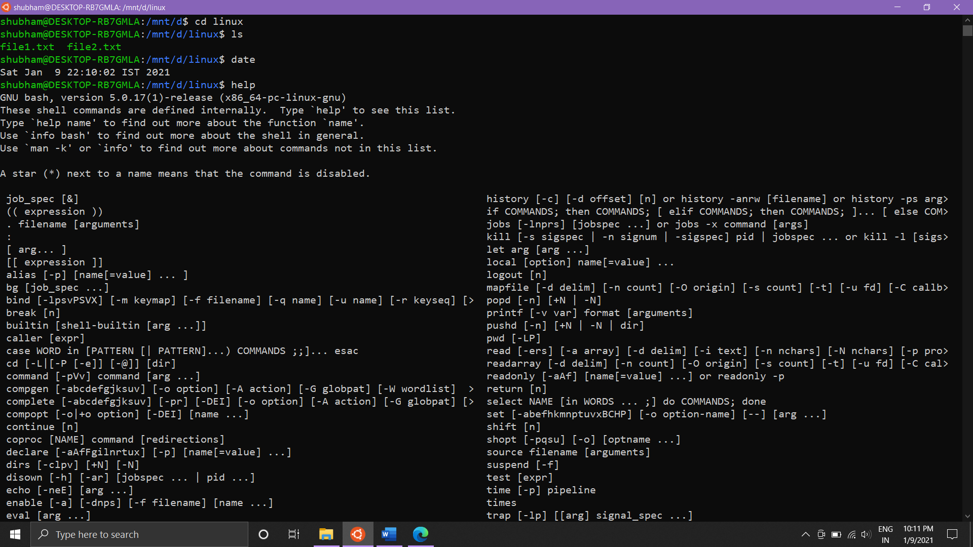

4-> info- read Info documents

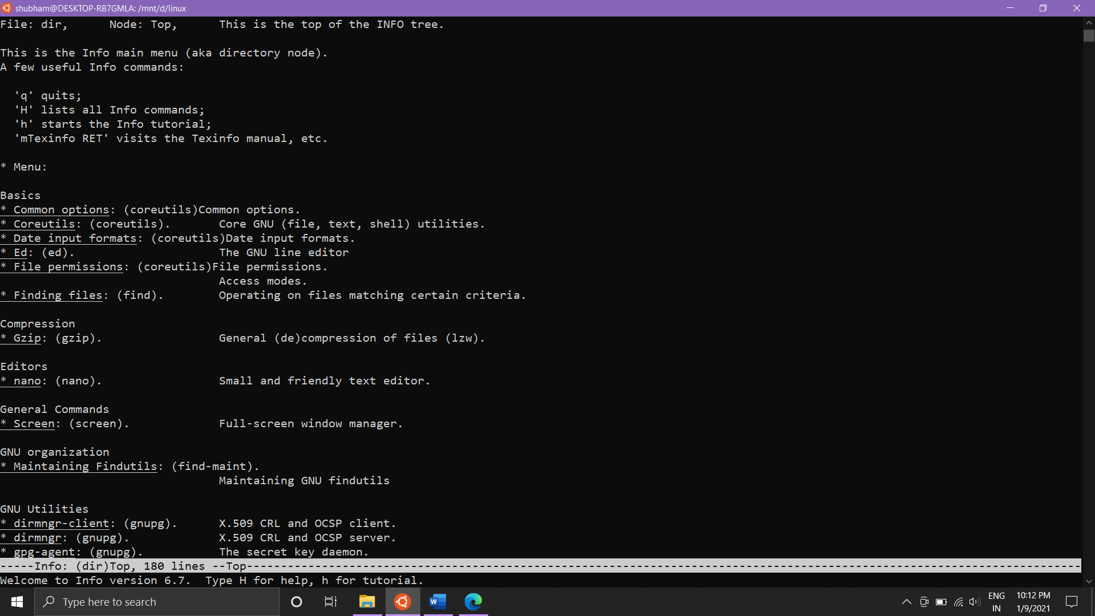

5-> man – an interface to the on-line reference manuals

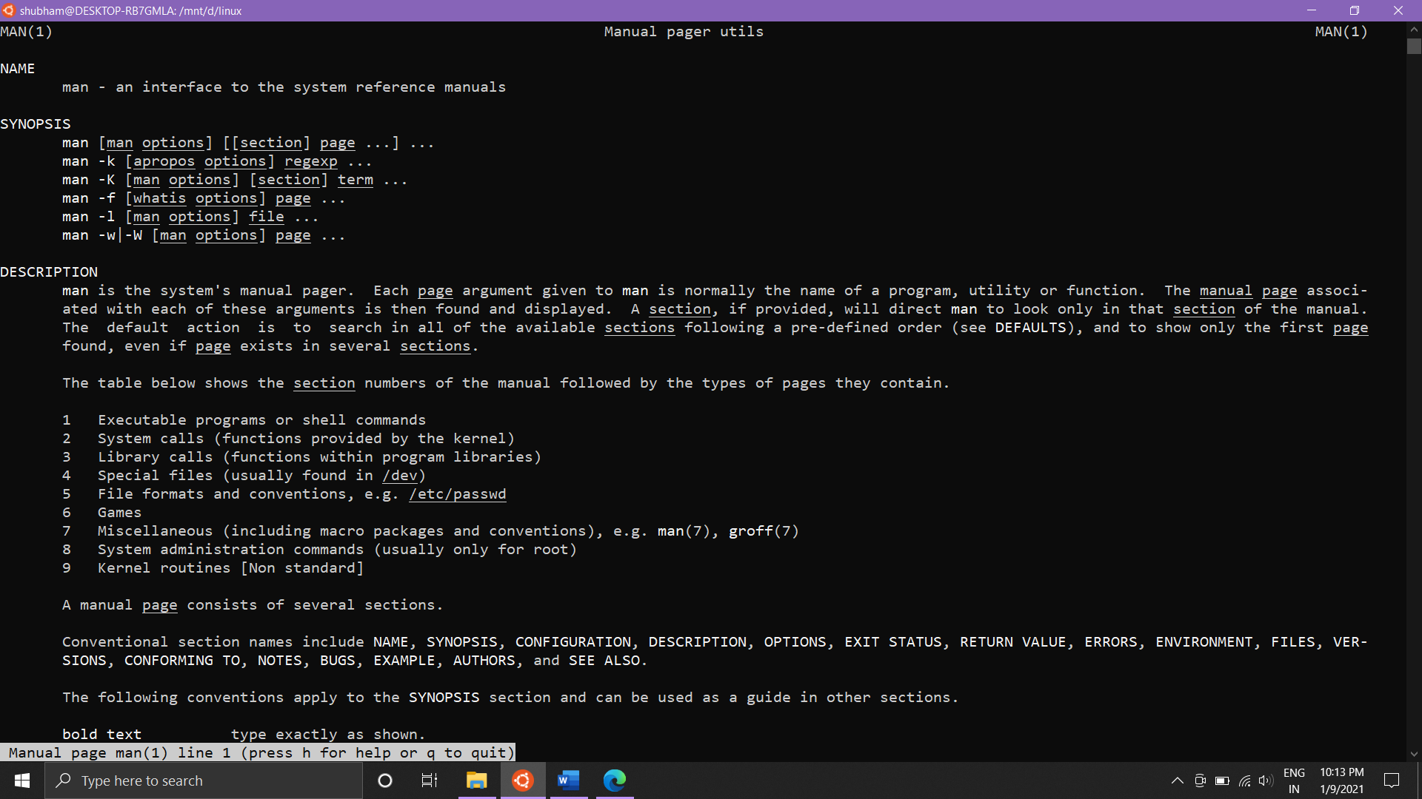

6-> who – show who is logged in

7-> pwd – print name of current/working directory

8-> cat – concatenate files and print on the standard output

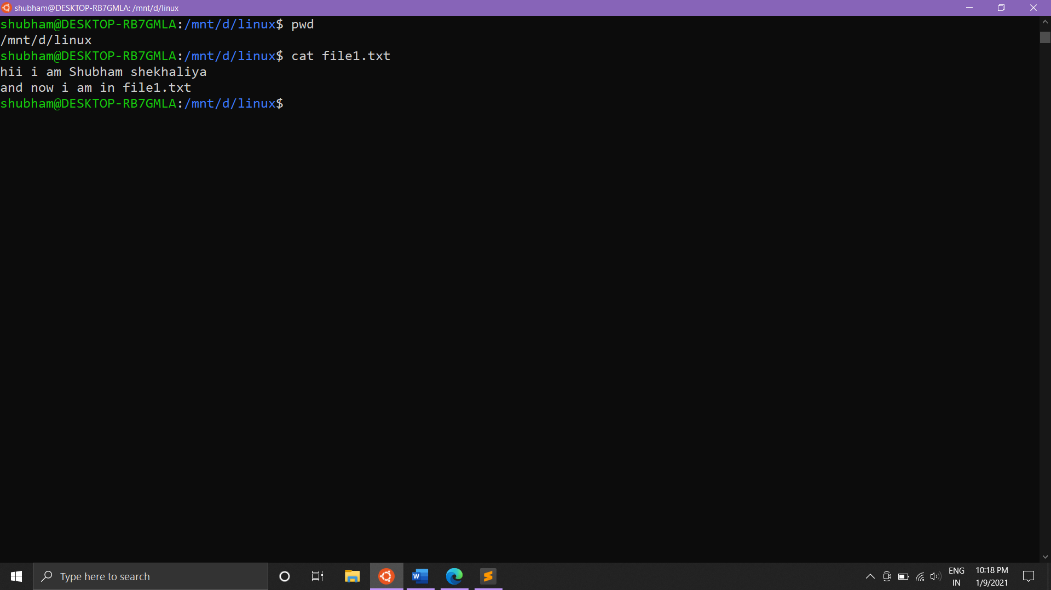

9-> more – Open a file for interactive reading, allowing scrolling and search(in forward direction only).

10->mv – move or rename files and directories

11-> rm – remove files and directories

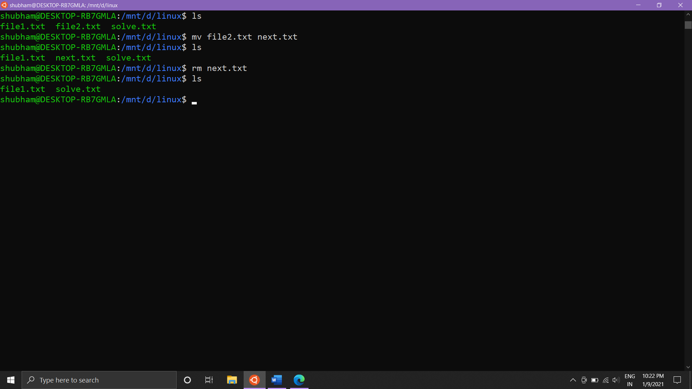

12-> chmod - Change the access permissions of a file or directory.

Eg. Give the [u]ser rights to [r]ead and [w]rite to a file/directory: chmod u+rw {{file_or_directory}}

13-> Whoami - Print the username associated with the current effective user ID.

14-> Logout - logout command allows you to programmatically logout from your session. causes the session manager to take the requested action immediately.

$ logout

- User gets logged out

15-> wc – count lines, words or bytes

16-> Grep - Matches patterns in input text. Supports simple patterns and regular expressions.

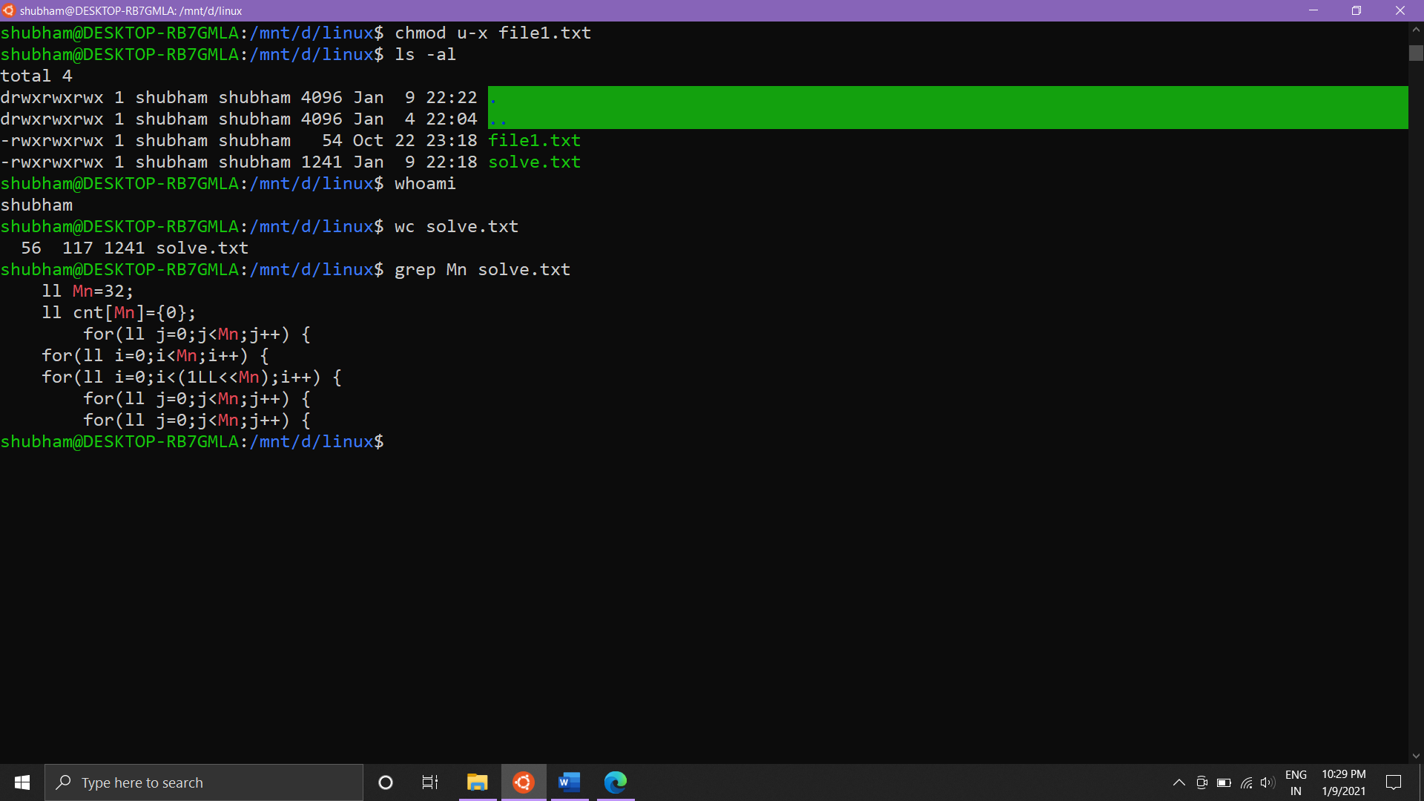

17-> Sort - Sort lines of text files.

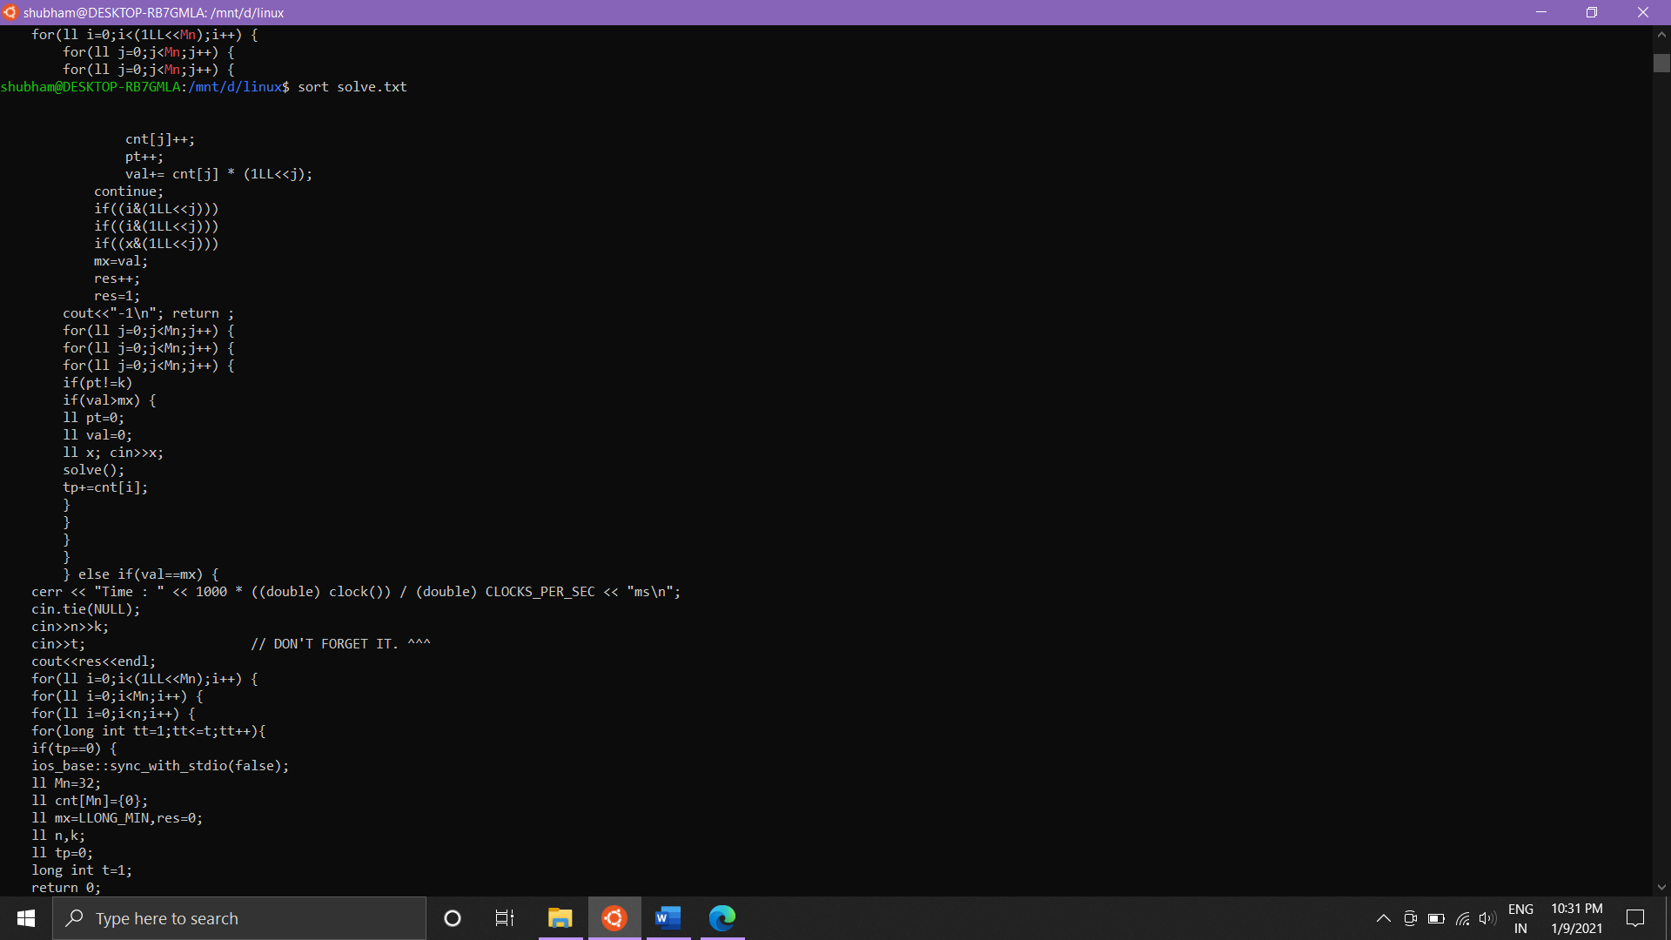

18-> Mkdir - make directory

19-> Rmdir - delete empty directory

20-> Cd - change directory

21-> Tail - Display the last part of a file.

22-> Cmp - Compare two files.

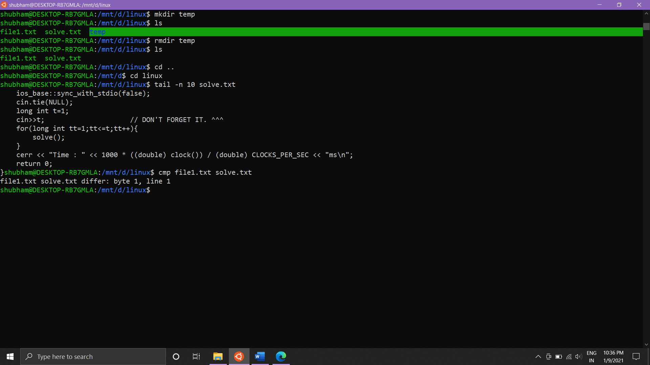

23-> Diff - Compare files and directories.

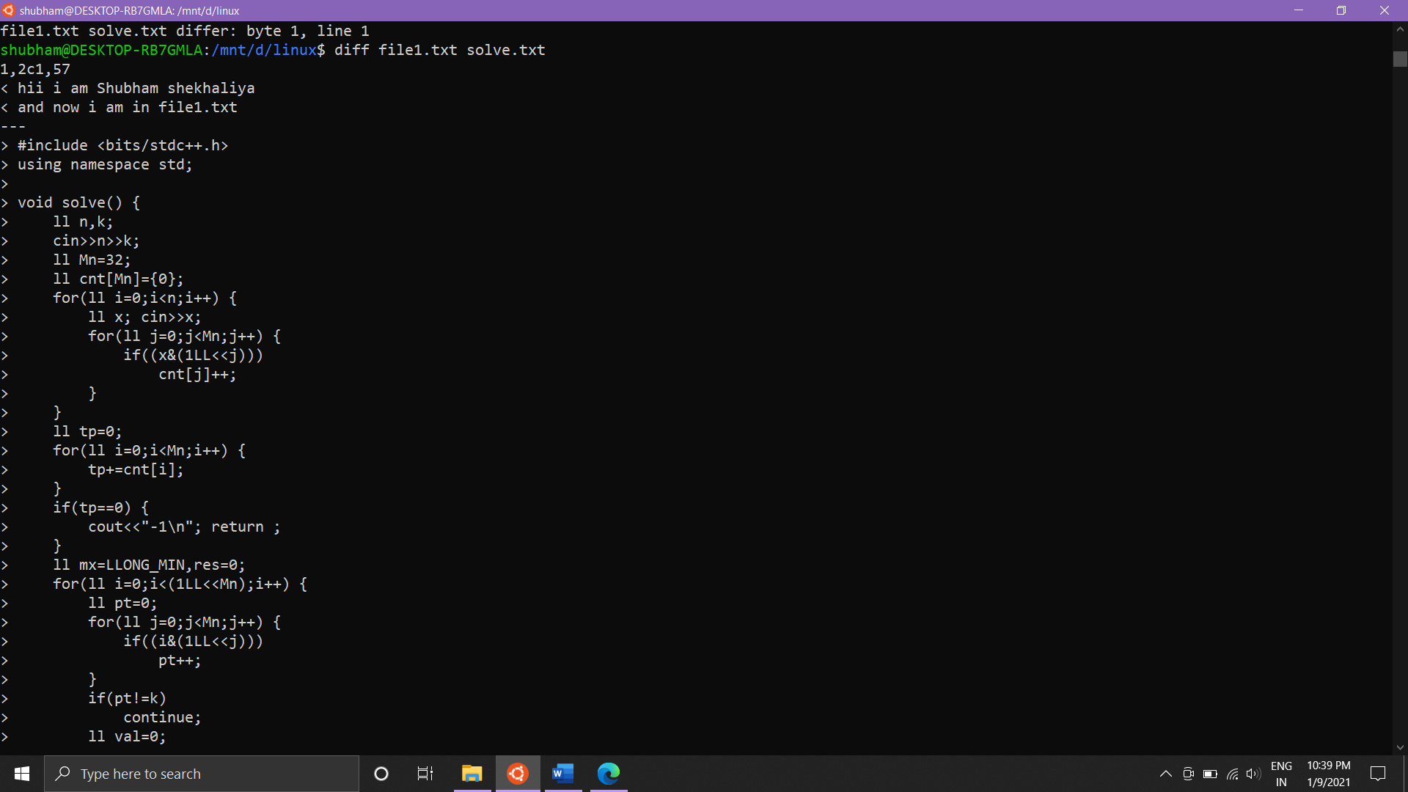

24-> Cp - Copy files and directories.

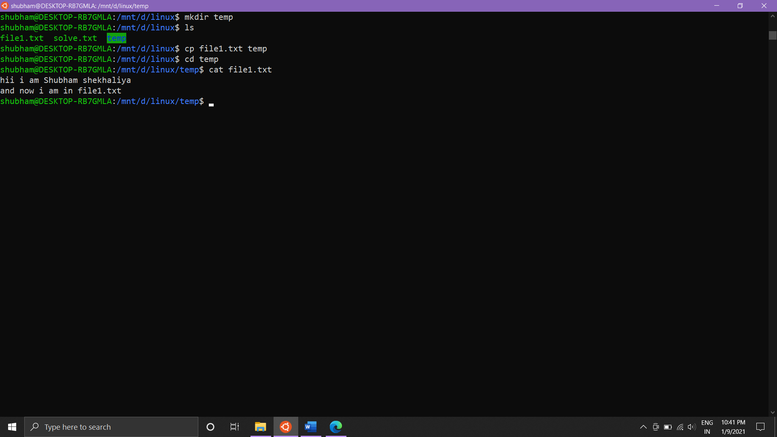

25-> Clear - clear screen of terminal

26-> Du - Disk usage: estimate and summarize file and directory space usage.

Disk usage of file MIT in KB and MB is shown above.

27-> Df - Gives an overview of the file system disk space usage

28-> Uname - Print details about the current machine and the operating system running on it.

29-> Apt-get - Debian and Ubuntu package management utility. Search for packages using apt-cache.

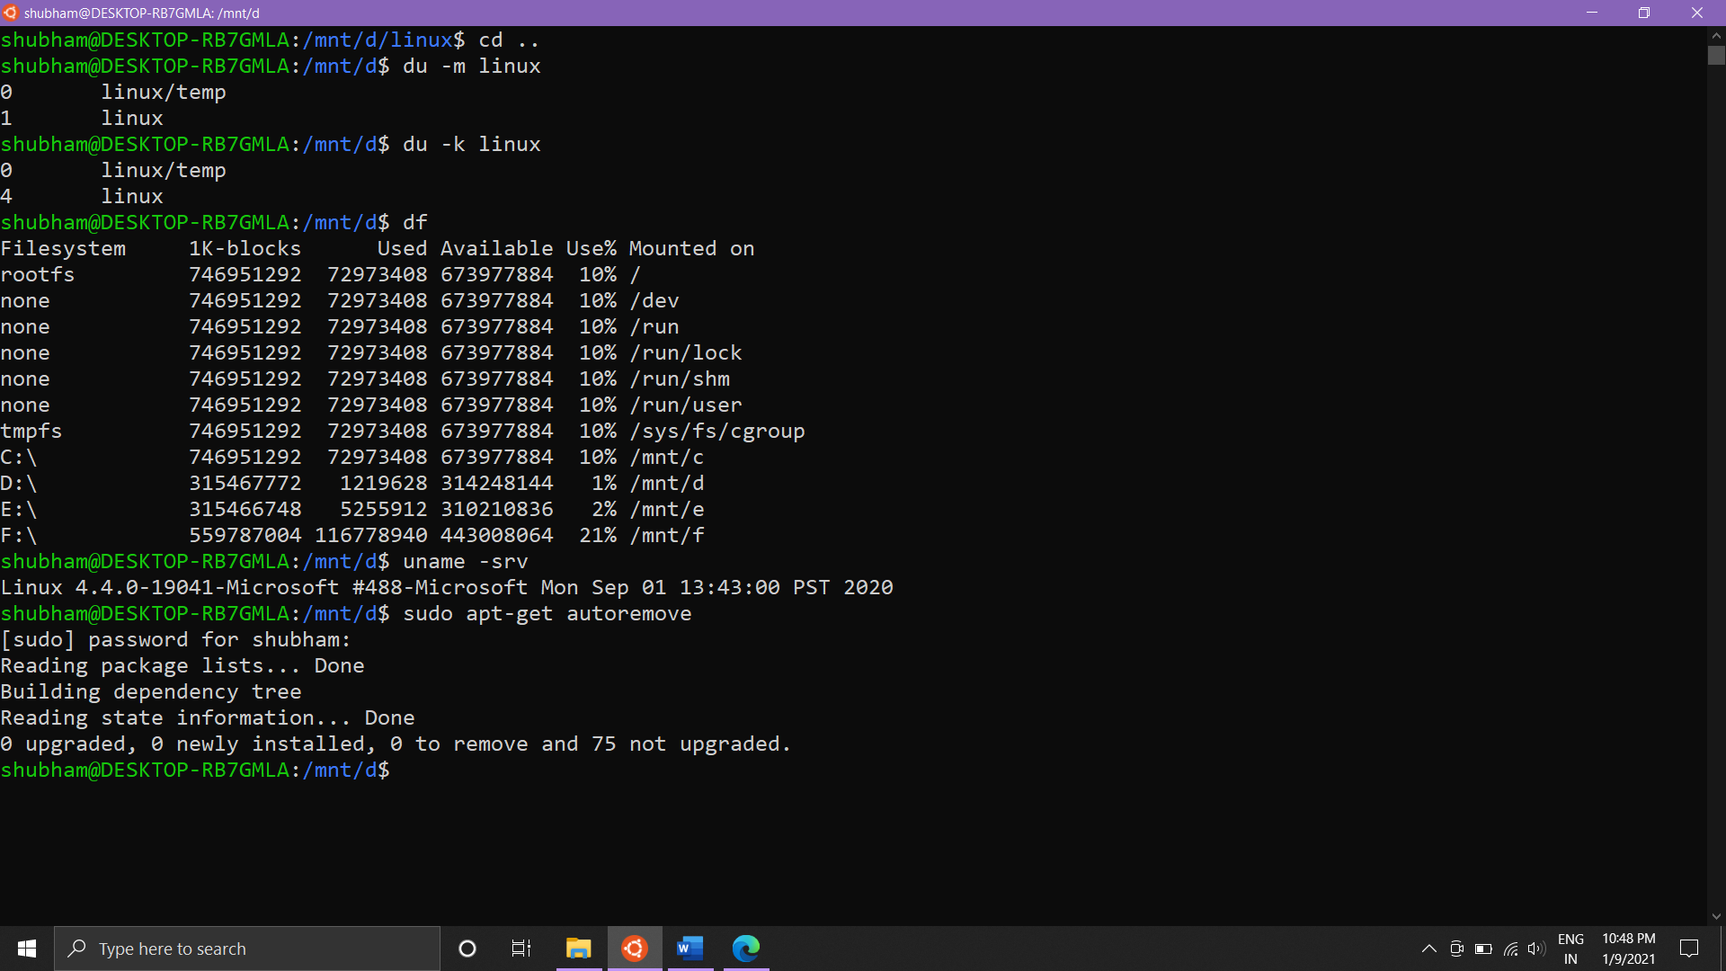

30-> Find - Find files or directories under the given directory tree, recursively

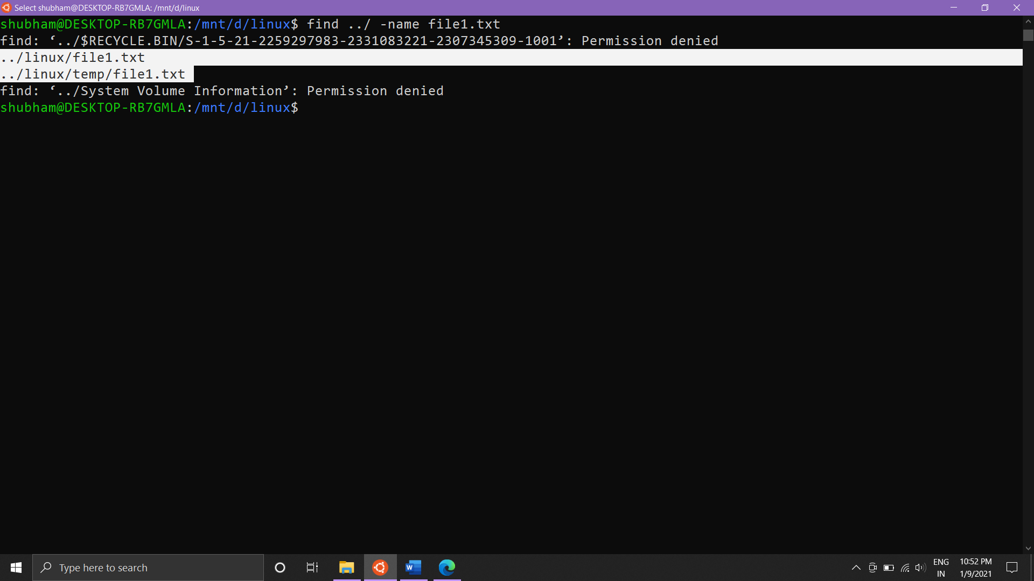

31-> wget – Download files from the web. Supports HTTP, HTTPS and FTP

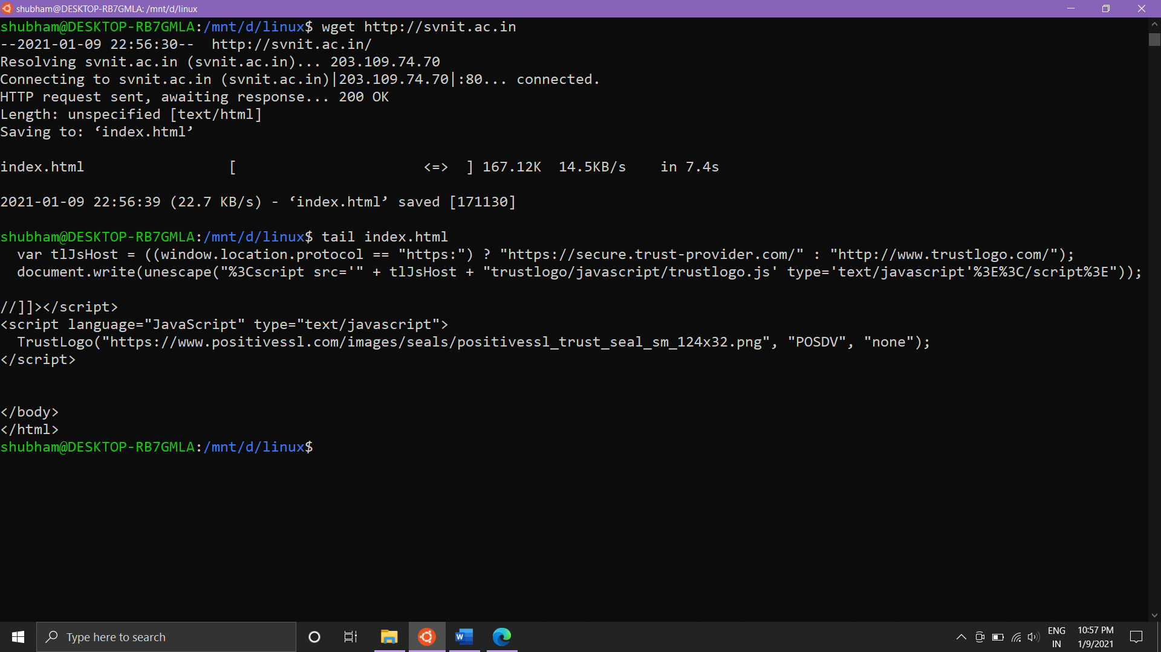

32-> top- display dynamic real time information about running processes

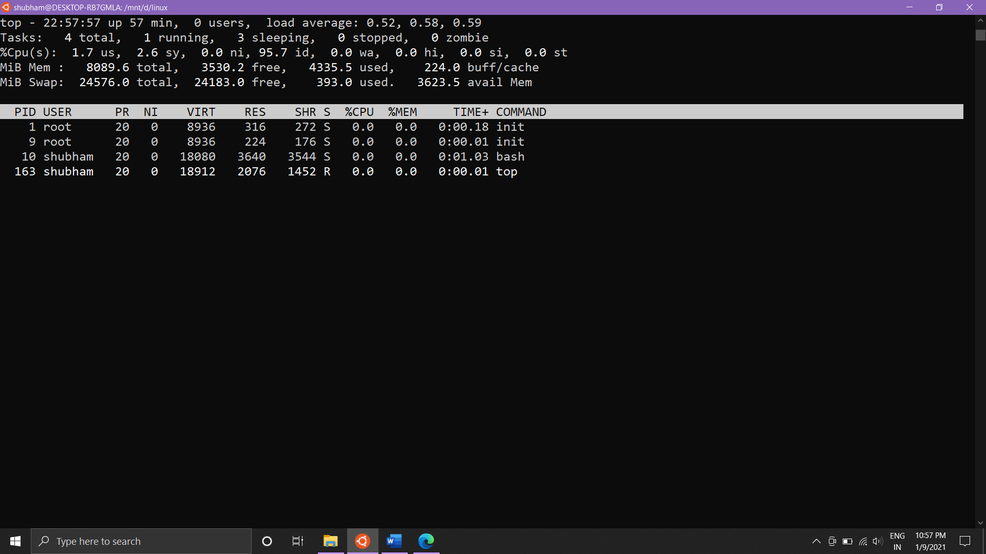

33-> mpstat – report CPU statistics

34-> netstat – display network related information such as open connections, open socket ports, etc.

35-> sar – monitor performance of various linux subsystems Displays performance every 3 seconds.

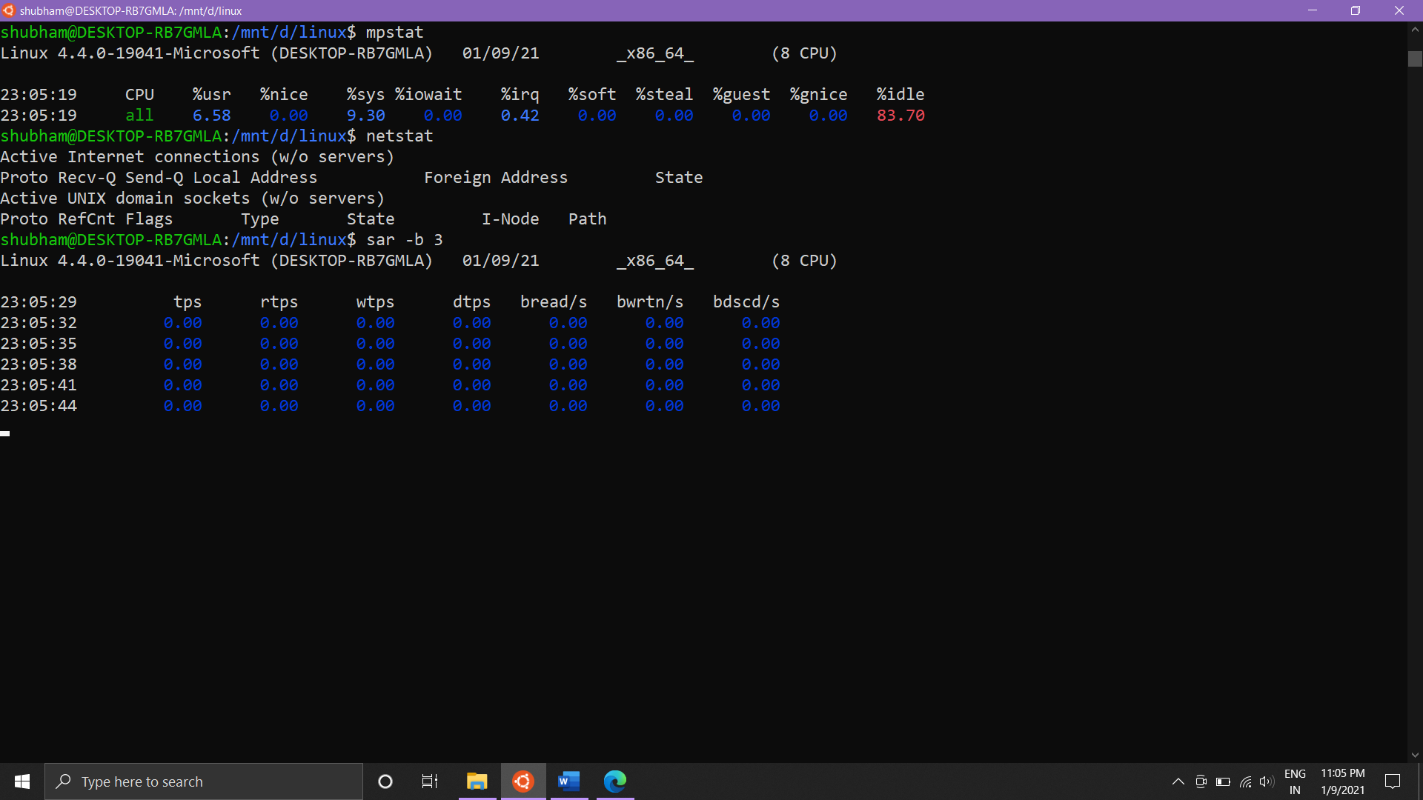

**(2) Linux commands related with process:**

1-> Ps - Information about running processes. Eg. ps aux lists all processes.

2-> Kill - Sends a signal to a process, usually related to stopping the process.All signals except for SIGKILL and SIGSTOP can be intercepted by the process to perform a clean exit.

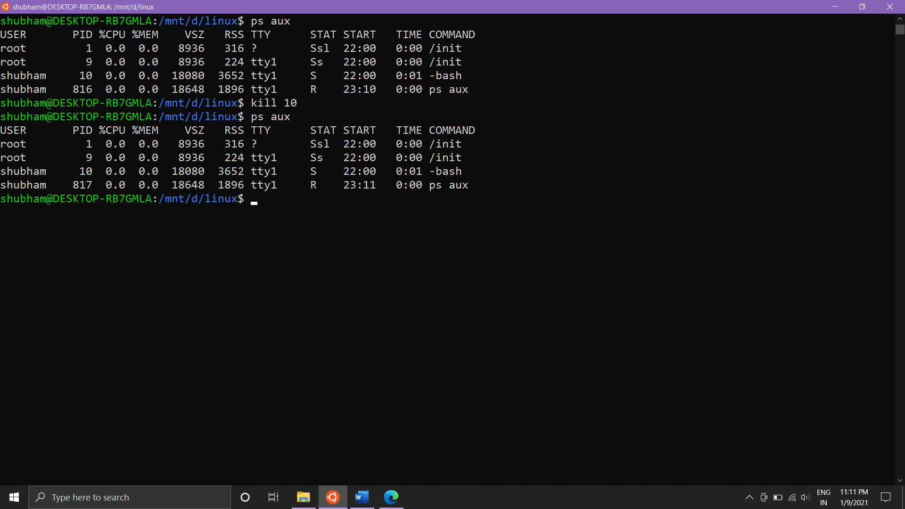

3-> Background processes with & -> moves the process to background

Eg. Sleep command is moved to background using & and then using fg we bring it to foreground and we get a delay of 5 seconds.

